Foothills Rural Planning Organization
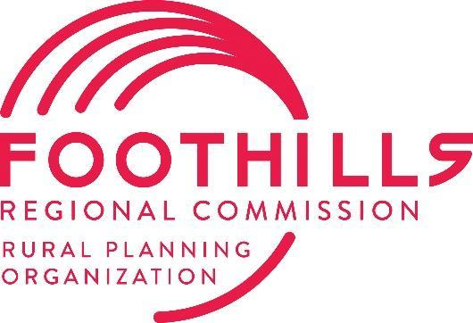
Transportation Advisory Committee (TAC)
Meeting Agenda
145 College Drive, Rutherfordton, NC 28139
Tuesday, January 13, 2026, at 1:00 PM

Welcome and Housekeeping Items
- Call to Order & Quorum Check (Mayor Dancy)
- Ethics Reminder* (Mayor Dancy)
- Agenda Approval or Modifications (Mayor Dancy)
- Public Comment
Action Items
- Approval of the 1-13-2026 TAC Minutes (Mayor Dancy)
- Approval of Draft FY27 PWP
- Approval of Draft Local Input Point Methodology
- FY25 PWP Amendment for SPR Study
Presentation
- Thermal Belt Rail Trail Extension Feasibility Study (Magnolia Long)
Informational Items
- Project Updates & Ethics Filing Reminder (Magnolia Long)
- NCDOT Division 13 Project Updates (Doug Phillips)
- NCDOT Division 14 Project Updates (Steve Williams)
- TPD Updates (Gerald Carter)
- General Announcements

Adjournment - Next Meeting: Tuesday, May 12, 2026
*In accordance with the State Government Ethics Act, it is the duty of every TAC member to avoid conflicts of interest. If anyone has a conflict of interest with respect to any matters coming before the TAC today, please identify the conflict and refrain from any participation in the matter involved.

