Foothills Rural Planning Organization
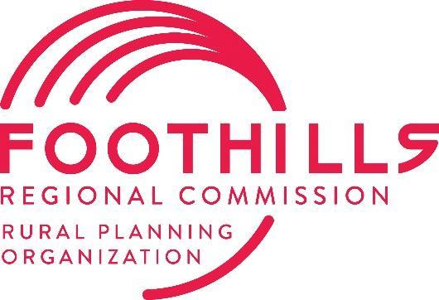
Transportation Advisory Committee (TAC)
Meeting Agenda
289 N Main Street, Rutherfordton, NC 28139
Tuesday, July 8, 2025, at 1:00 PM

Welcome and Housekeeping Items
- Call to Order & Quorum Check (Mayor Dancy)
  - Jimmy Dancy called the meeting to order at 1:00 pm.
- Ethics Reminder* (Mayor Dancy)
- Agenda Approval or Modifications (Mayor Dancy)
  - Motion to approve the agenda as written: Carol Pritchett
    - Seconded: Peter O’Leary
    - Vote: Unanimous
- Public Comment
Action Items
- Approval of 5-13-2025 TAC Minutes (Mayor Dancy)
  - Motion to approve the minutes: Chuck McGrady
    - Seconded: Carol Pritchett
    - Vote: Unanimous
- Draft P8 Project List Review & Approval (Magnolia Long)
  - Motion to approve Draft P8 Project List as presented: Carol Pritchett
    - Seconded: Chuck McGrady
    - Vote: Unanimous
Informational Items
- Organization Updates (Magnolia Long)
  - FRPO to host NCARPO Conference July 24-25th
  - Status of TBRT/Ellenboro SPR Study: Study to be completed by fall 2025. Public Survey to be released and completed by mid-August.
  - SS4A Regional Safety Action Plan Update: FRC under contract with Bolten & Menk, study kick-off will happen soon.
- NCDOT Division 13 Project Updates (Chad Young)
  - Chad Young provided a sheet and reviewed construction updates and project development progress.
- NCDOT Division 14 Project Updates (Steve Williams)
  - Steve Williams provided a sheet and reviewed construction updates and project development progress.
- TPD Updates (Gerald Carter)
  - Gerald Carter is officially FRPO and SWRPO’s TPD coordinator! Gerald provided updates regarding functional classification review. Gerald congratulated FRPO TAC on the NADO award. Gerald stated that TPD will be finalizing dates on FY26.
- General Announcements
  - Chuck McGrady announced that the Saluda Grade was purchased in June from Norfolk Southern.
- Adjournment
  - Motion to adjourn at 1:19: Erin Adams
    - Seconded: Chuck McGrady
    - Vote: Unanimous

Jurisdiction | TAC Representative | Present
Rutherford County | Donnie Haulk | ☐
Rutherfordton | Jimmy Dancy (Chair) | ☒
Forest City | Steve Holland | ☒
Spindale | Rosaleen Francis | ☒
Lake Lure | Carol Pritchett | ☒
Chimney Rock | Peter O’Leary | ☒
McDowell County | Vacant | ☐
Marion | Don Ramsey | ☒
Old Fort | Erin Adams | ☒
Polk County | David Moore | ☐
Tryon | Vacant | ☐
Columbus | Brent Jackson | ☒
Saluda | Vacant | ☐
Board of Transportation, Division 14 | Chuck McGrady | ☒
Board of Transportation, Division 13 | William Clarke | ☐
 | Total Members Present: | 9
Jurisdiction | Staff Present | Present
Foothills Regional Commission | Magnolia Long | ☒
Foothills Regional Commission | Alan Toney | ☐
NCDOT Division 13 | Stephen Sparks | ☒
NCDOT Division 13 | Chad Young | ☒
NCDOT Division 14 | Steve Williams | ☒
NCDOT Division 14 | Elias Hord | ☐
NCDOT Division 14 | Troy Wilson | ☐
NCDOT TPD | Gerald Carter | ☒

