Foothills Rural Planning Organization
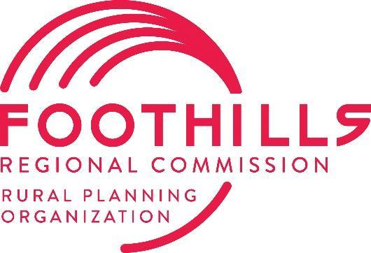
Transportation Advisory Committee (TAC)
Meeting Agenda
289 N Main Street, Rutherfordton, NC 28139
Tuesday, July 8, 2025, at 1:00 PM

Welcome and Housekeeping Items
- Call to Order & Quorum Check (Mayor Dancy)
- Ethics Reminder* (Mayor Dancy)
- Agenda Approval or Modifications (Mayor Dancy)
- Public Comment
Action Items
- Approval of the 3-25-2025 TAC Minutes (Mayor Dancy)
- Approval of 5-13-2025 TAC Minutes (Mayor Dancy)
- Draft P8 Project List Review & Approval (Magnolia Long)
Informational Items
- Organization Updates (Magnolia Long)
  - FRPO to host NCARPO Conference July 24-25th
  - Status of TBRT/Ellenboro SPR Study
  - SS4A Regional Safety Action Plan Update
- NCDOT Division 13 Project Updates (Hannah Smith)
- NCDOT Division 14 Project Updates (Steve Williams)
- TPD Updates (Gerald Carter)
- General Announcements

Adjournment - Next Meeting: Tuesday, September 9th, 2025
*In accordance with the State Government Ethics Act, it is the duty of every TAC member to avoid conflicts of interest. If anyone has a conflict of interest with respect to any matters coming before the TAC today, please identify the conflict and refrain from any participation in the matter involved.

