Foothills Rural Planning Organization
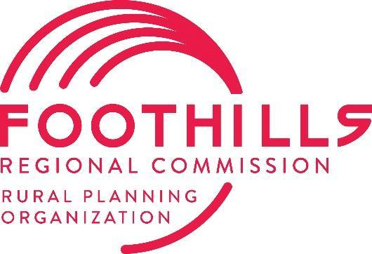
Transportation Advisory Committee (TAC)
Meeting Agenda
241 Clubhouse Dr, Rutherfordton, NC 28139
Tuesday, November 12, 2024, at 1:00 PM

Welcome and Housekeeping Items

Call to Order
Chairman Jimmy Dancy called the meeting to order at 1:04 PM.
Ethics Reminder
Chairman Jimmy Dancy read the Ethics Reminder to the board.

Agenda Approval or Modifications
- Motion to approve the agenda: Woody Ayers
- Seconded by: Carol Pritchett
- Vote: Approved unanimously

Public Comment
No public comments were received.

Action Items

Approval of 9-10-2024 TAC Minutes
- Modification: Correct the name from "Hannah Cook" to "Hannah Smith."
- Motion to approve with modification: Woody Ayers
- Seconded by: Carol Pritchett
- Vote: Approved unanimously

Informational Items

County LIP Division Needs Assignment
Presenter: Magnolia Long
- Magnolia summarized discussions with the TAC Chair and Vice-Chair regarding Division Needs Local Input Point Assignments (LIPs).
- It was agreed that assigning LIPs for Division needs projects, especially in light of Hurricane Helene and current local commitments, is not the best use of board resources.
- Moving forward, the board will include a clause for submitting LIPs in the event of a natural disaster.

NCDOT Division 13 Project Updates
Presenter: Hannah Smith
- A project update sheet for Division 13 was distributed to all attendees.
- Highlights:
  - Raise Grant Public Comment Period: Closing soon.
  - Roundabout on N Washington St: Notice to proceed issued.
  - Resurfacing Projects: Pausing for seasonal limitations starting November 15.
  - I-40 Sugarhill Road Exit Lighting: Expected completion by the end of November.
  - Wright Brothers Project: Construction on the 221 Bypass pulled to address storm-related damages, extending through January.
  - Chimney Rock/Lake Lure Pedestrian Connection Feasibility Study: The funded FY25 SPR study will not continue due to hurricane damages. The money awarded for the project will be reallocated to the local communities once RPO receives information and guidance on use of funds.

NCDOT Division 14 Project Updates
Presenter: Steve Williams
- A project update sheet for Division 14 was distributed to all attendees.
  - The highlighted yellow construction projects have been moved out.
- Key points included debris removal being conducted through the Army Corps of Engineers.

TPD Updates
Presenter: James Upchurch
- James provided updates on long-range planning and storm recovery efforts.
- NCEM is developing a dashboard to quantify infrastructure repair progress and costs related to Hurricane Helene.
- Discussions included how the hurricane has impacted existing infrastructure.
- James encouraged board members to invite him to local meetings focused on long-term recovery planning.

General Announcements
No announcements were made.

Adjournment
The meeting was adjourned at 1:42.
- Motion to adjourn: Erin Adams
- Seconded by: Carol Pritchett
- Vote: Approved unanimously

